Markov Decision Process Representations

Consider the MDP shown in the state-transition diagram below.

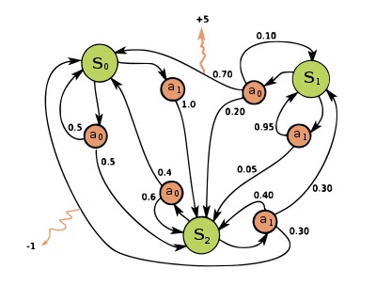

Complete the tabular (matrix) representations of the T(s, a, s’) and R(s, a, s’).

T R

|  |  |  |  |  |  |  |  |
| --- | --- | --- | --- | --- | --- | --- | --- |
|  | s0 | s1 | s2 |  | s0 | s1 | s2 |
| s0, a0 | 0.5 | 0.0 | 0.5 |  | 0.0 | 0.0 | 0.0 |
| s0, a1 | 0.0 | 0.0 | 1.0 |  | 0.0 | 0.0 | 0.0 |
| s1, a0 | 0.7 | 0.1 | 0.2 |  | 5.0 | 0.0 | 0.0 |
| s1, a1 | 0.0 | 0.95 | 0.05 |  | 0.0 | 0.0 | 0.0 |
| s2, a0 | 0.4 | 0.0 | 0.6 |  | 0.0 | 0.0 | 0.0 |
| s2, a1 | 0.3 | 0.3 | 0.4 |  | -1.0 | 0.0 | 0.0 |

Next, take a different MDP, represented below in matrix form, and draw its state-transition diagram.

T R

|  |  |  |  |  |  |
| --- | --- | --- | --- | --- | --- |
|  | s0 | s1 |  | s0 | s1 |
| s0, a0 | 0.8 | 0.2 |  | 2 | 2 |
| s0, a1 | 0.5 | 0.5 |  | 5 | 4 |
| s1, a0 | 0.5 | 0.5 |  | 2 | 2 |
| s1, a1 | 0.2 | 0.8 |  | 4 | -10 |

